F-37 -

Functionality
Down Payment is a function that uses Special GL indicators. Special GL Transactions allow the user to post the document to an alternative GL account instead of “normal” vendor’s reconciliation account. They are defined in Customizing for Vendors and Customers reconciliation accounts.

Scenario
You want to post a down payment request for a customer.

Requirements
Defined GL indicators, Customer Master.

Menu Path | Accounting → Financial Accounting → Accounts Receivable → Document entry → Down payment → F-37 - Request
Transaction Code | F-37

1. Double click on F-37 – Request.

Customer Down Payment Request: Header Data

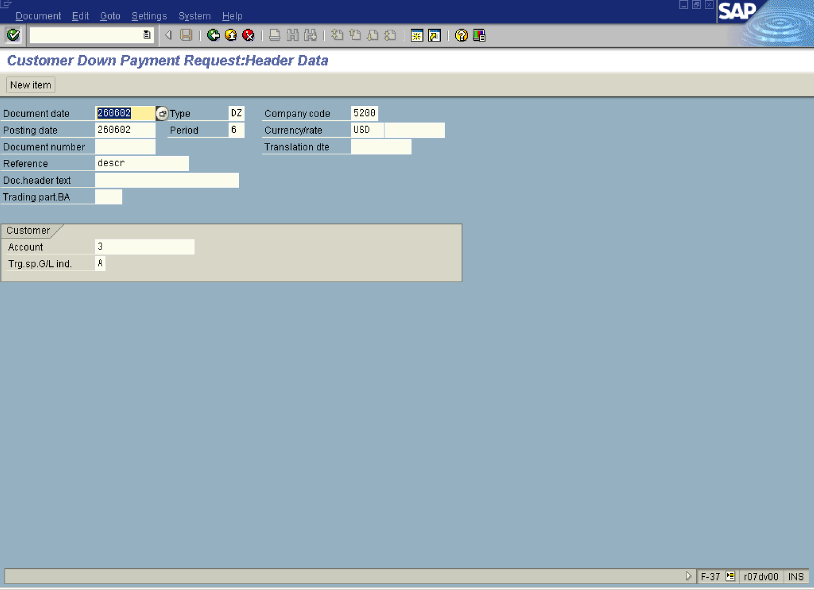

2. Update the following fields:

Field Name | Field Description | Values
Document date | Date the transaction occurred | Example: 260602
Type | Document type code | Example: DZ
Company code | Code identifying a separate legal entity for which a separate set of accounts is maintained for external reporting purposes | Example: 5200
Posting date | Date that the business transaction occurred | Example: 260602
Currency/rate | Code identifying the currency used in the transaction | Example: USD
Reference | Description of the Reference. | Example: descr
Account | Code identifying the General Ledger, Vendor, or Customer account | Example: 3

3. Click Enter Button to confirm your entries.

4. Now you need to enter the document line item:

Customer Down Payment Request:Add Customer item

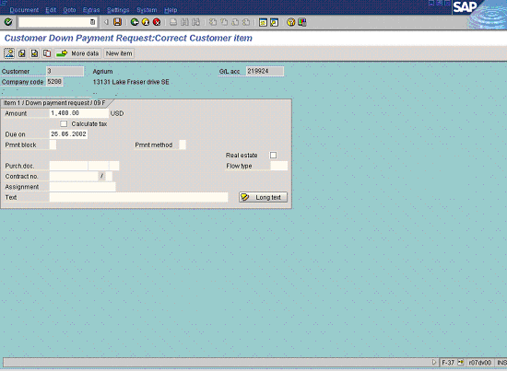

5. Update the following fields:

Field Name | Field Description | Values
Amount | Amount of the line item | Example: 1400
Due on | Date when the down payment is due | Example: 260602

6. Click Enter Button to confirm your entries.

7. Click Overview Button to display the document:

Customer Down Payment Request:Display Overview

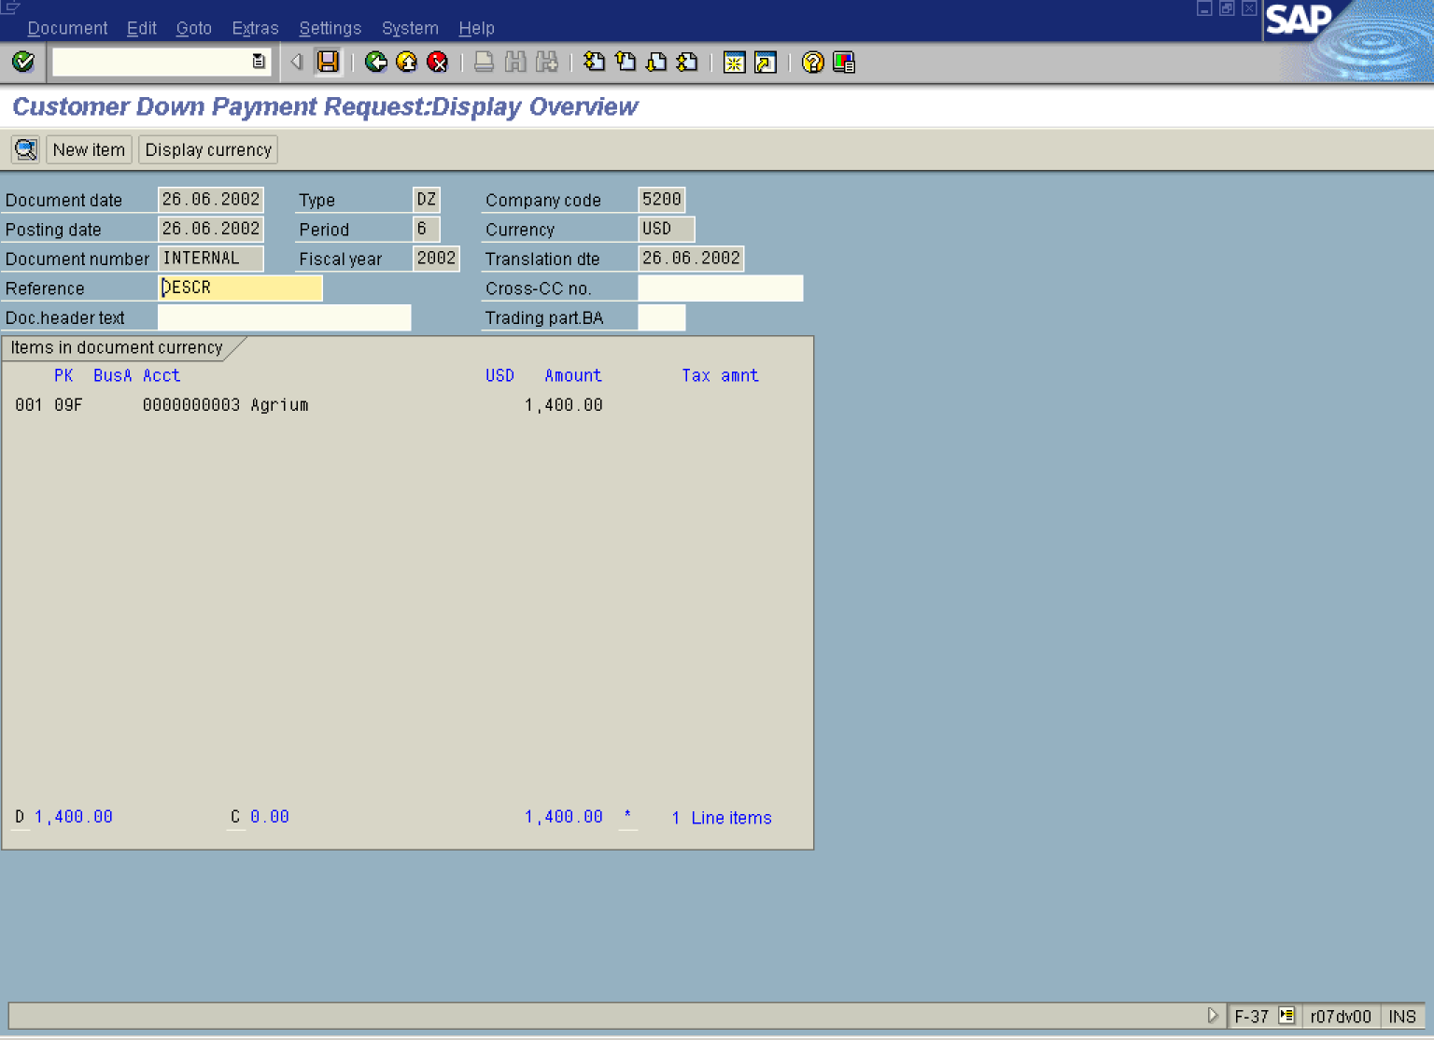

8. Click Save Button to post the document.

